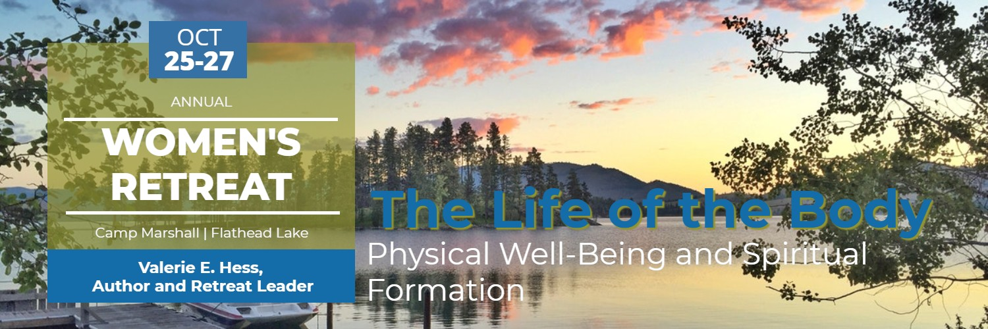
Women’s Retreat 2019
Name _________________________________________________________________________________________________
Address _______________________________________________________________ Zip___________________________
E-mail Address __________________________________________________________________________
Phone Number ________________________ Cell Phone Number ___________________________
Any dietary restrictions or food allergies? ________________________________________________________
_________________________________________________________________________________________________________
Any special needs (mobility needs/restrictions)? ________________________________________________
_________________________________________________________________________________________________________
Comments:___________________________________________________________________________________________
Sleeping Arrangements:

Most sleeping accommodations at camp are bunk beds. All sleeping accommodations are heated. Some rooms have access to an indoor toilet, others have outdoor toilet access. Please indicate your needs and preferences.

_____lower bunk only

_____handicap accessible bed or need access to electricity at night

_____indoor toilet access only

_____main floor accommodations (don’t want to negotiate stairs at night)

____Light Sleeper. Comments:___________________________________________________________________
If you are coming with a friend to the retreat and have already arranged to share space, please let us know and we will reserve bunks for the two of you. Otherwise, bunks will be first come, first served.

Keep in mind you will need to bring along a fitted twin sheet, plus a sleeping bag (or other bedding) and pillow.

PHOTO, PRESS, AUDIO, AND ELECTRONIC MEDIA RELEASE

I, ________________________________, hereby consent that the photographs and/or motion picture or videotape for which she/he posed, and/or audio recordings made of her/his voice may be used by Holy Spirit Episcopal Church, Missoula, Montana, its assignees or successors, in whatever way they desire, including television and electronic media.

IN WITNESS THEREOF I have hereunto set my hand, in the State of Montana, this ______________ day of ______________, 2______.

SIGNATURE: ____________________________________________________ DATE: _____________________________

Fee: $110 (financial assistance available, talk with Gretchen)
Reserve Your Spot by October 13th
Contact: Gretchen Strohmaier at 542-2167 or gretchen@holyspiritmissoula.org

Return registration form and fee to church office by October 13th

Holy Spirit Episcopal Church
130 South 6th Street East
Missoula, MT 59801

